Lehman VPN User Documentation for Windows
A VPN (virtual private network) allows users to securely connect to a private network from a public network. In this case Lehman faculty and staff are able to connect to the Lehman Network from anywhere. This allows them access resources that are regularly not available from off campus.

How to connect
To connect to the Lehman VPN you must download the VPN client. The VPN client can be downloaded from https://remote.lehman.edu/
The download and installation of the VPN client only needs to be done once. If you already have the VPN client installed you may skip to step 9.
- On any web browser navigate to https://remote.lehman.edu/ and log in with your Lehman username and password.
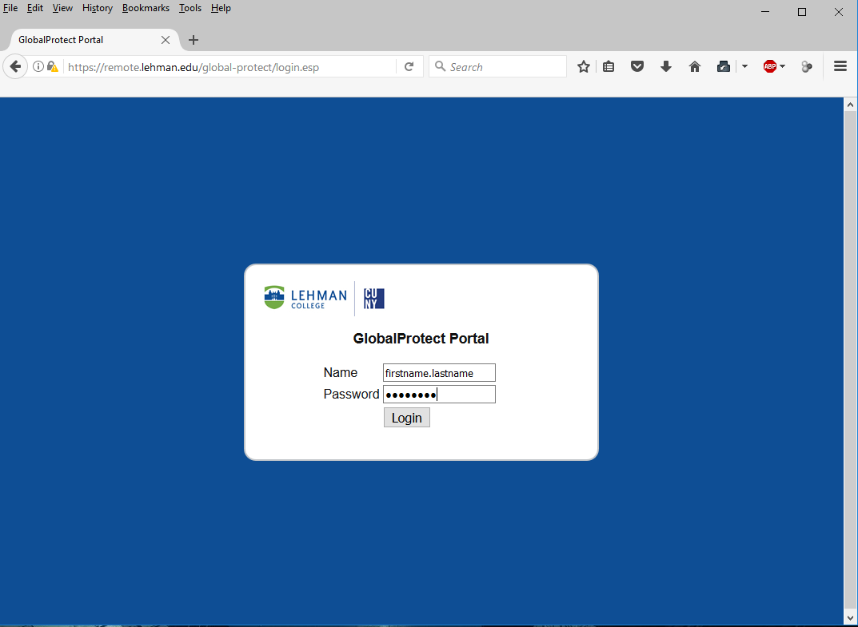

- Once authenticated you will be presented with 3 download links. Select the link that matches with your operating system.

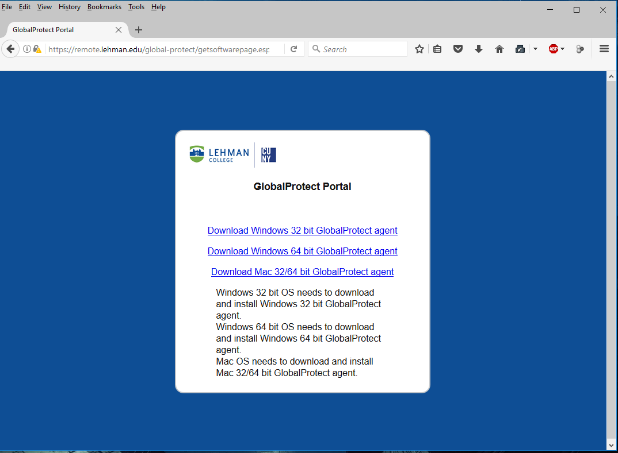
- Click on save file to download the installer. 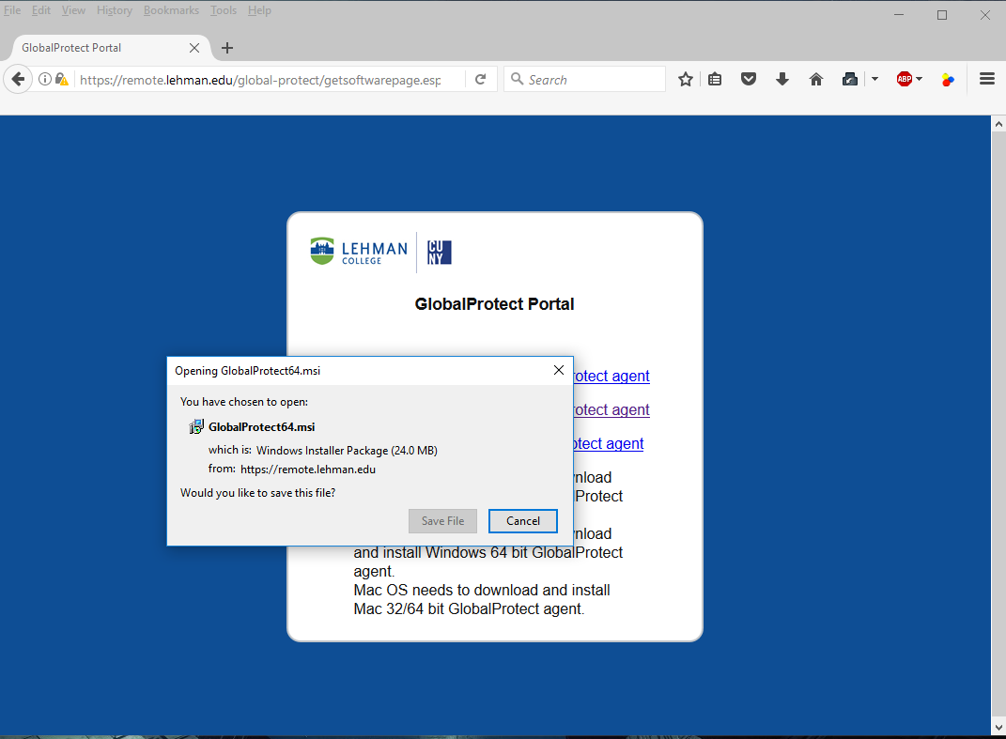
- Once the installer downloads. Double click to install.
Note: administrative privileges are required to install the software in your computer.

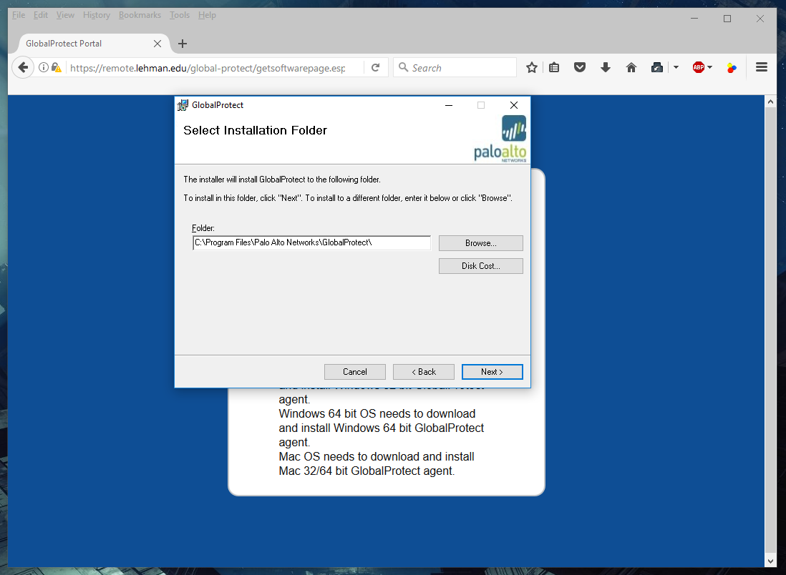

- Follow the steps in the install wizard to complete the installation.
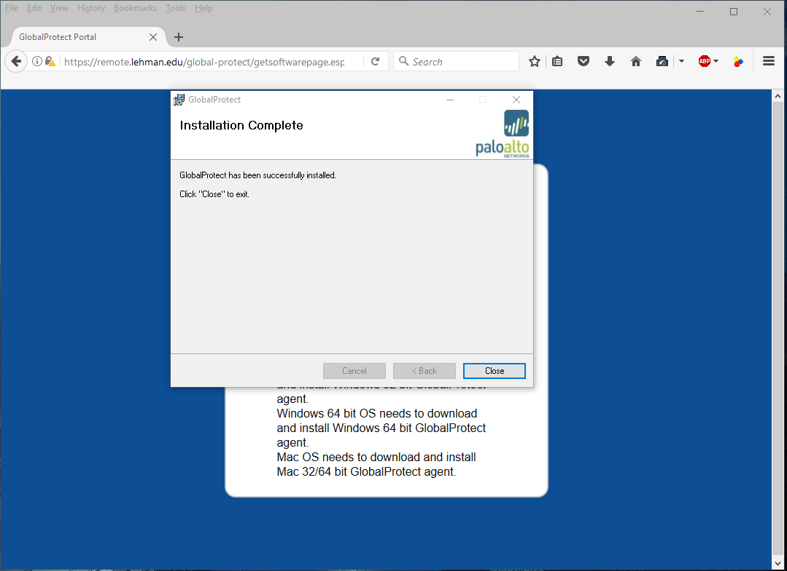
- Once installed, the application will launch automatically. Fill in the information accordingly and click on connect.
Portal: remote.lehman.edu
Username: Lehman username i.e. firstname.lastname
Password: Lehman password
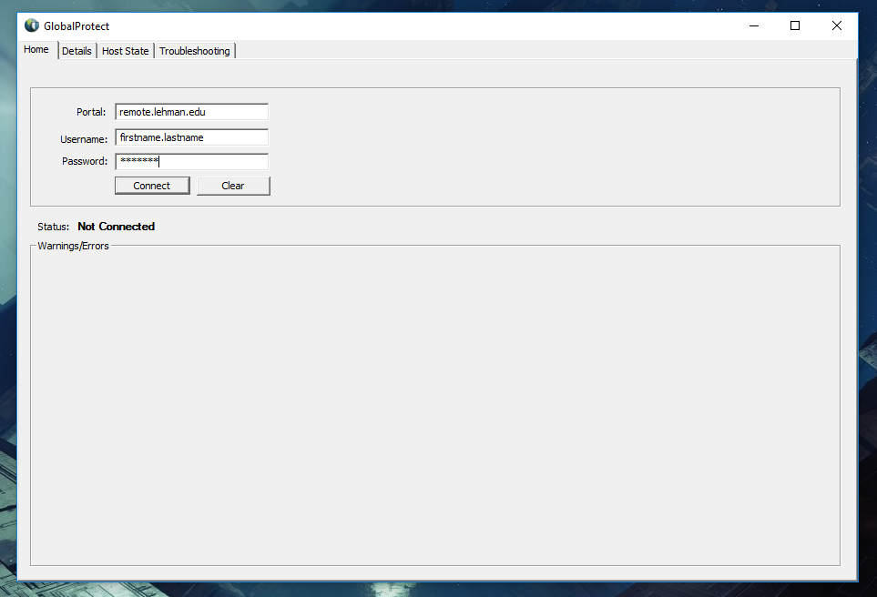
- If the connection is successful the status will say “Connected” as displayed below. At this point you should be able to access Lehman resources just as if you were on campus.
Once you are connected to the VPN you may access Lehman resources that are regularly only accessible from the campus network.

Launch VPN client from the desktop

- Go to the Windows notification area on the bottom right corner of your desktop.

- Right click on the Global Protect icon and click on “Connect”.
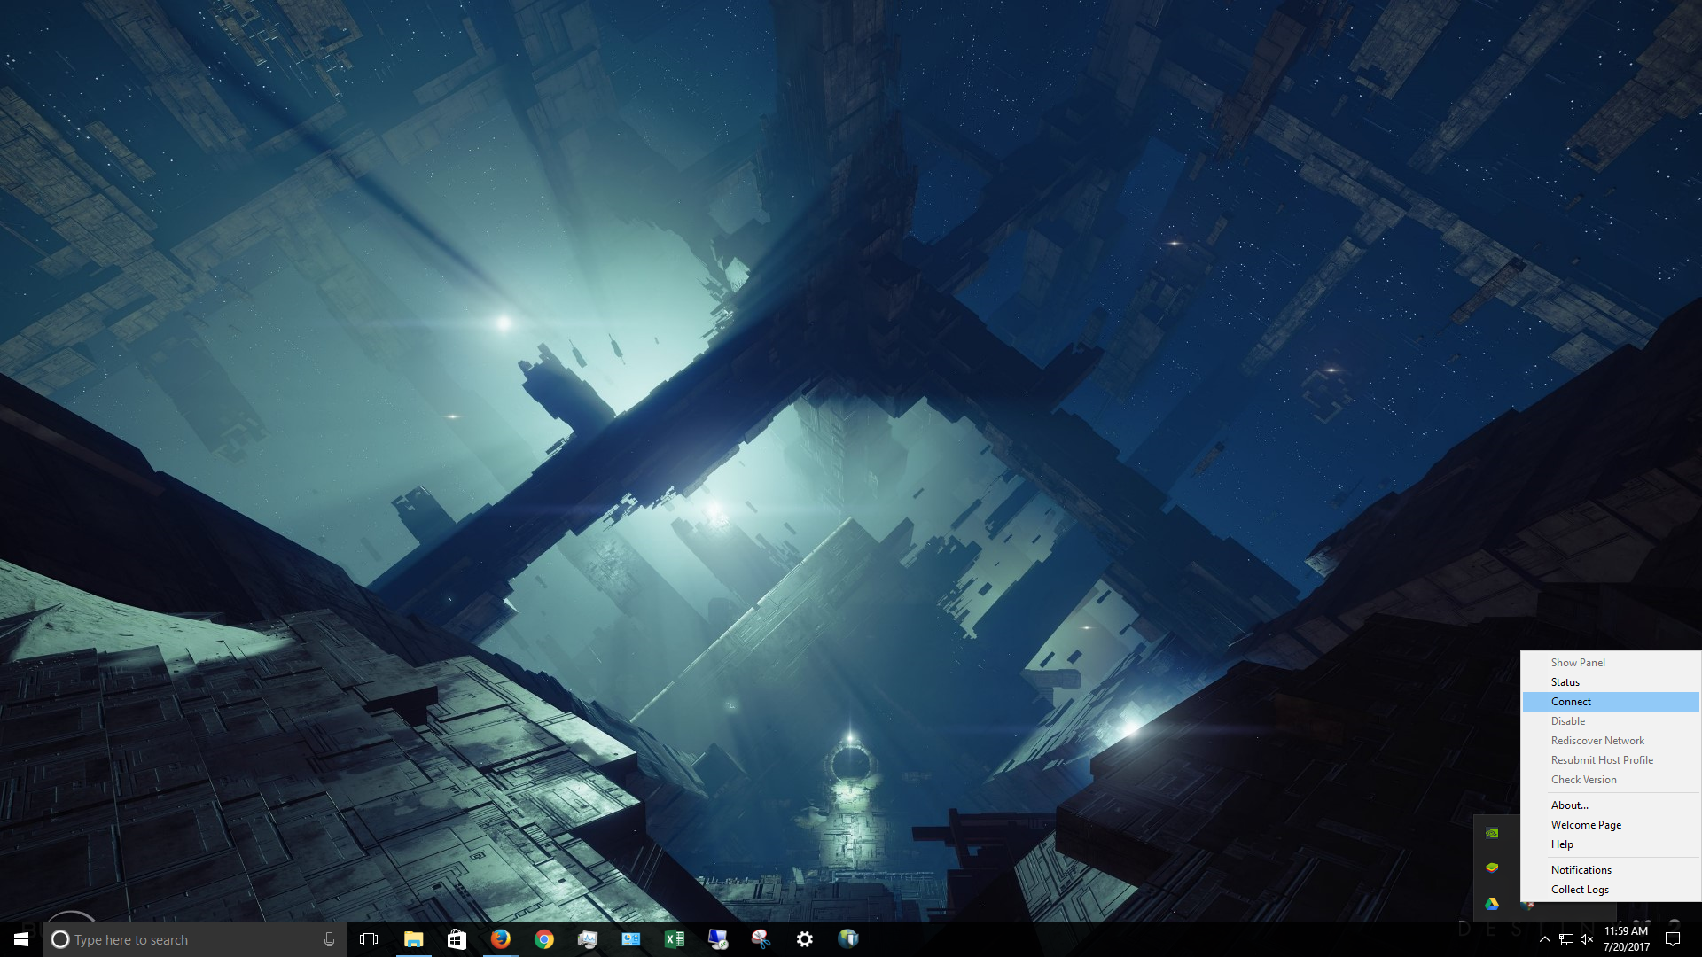

- Fill in the information accordingly and click on connect.
Portal: remote.lehman.edu
Username: Lehman username i.e. firstname.lastname
Password: Lehman password

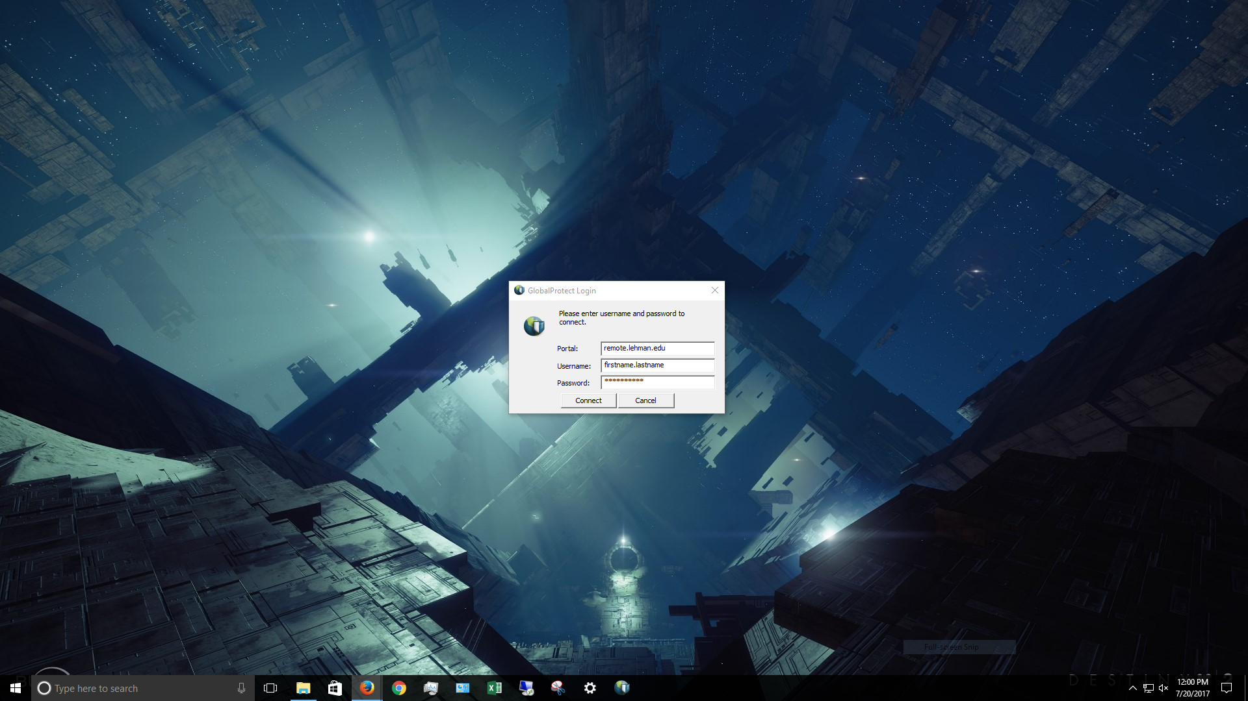

- If connected successfully, the icon on the notification area will say “Connected” as displayed below.

Once connected to the VPN you may access campus resources that are available only from the campus network. For example, faculty members that conduct research on campus servers may establish a remote session or SSH connection to their server.

- To disconnect, right click on the Global Protect icon and click on “Disconnect”.
